# TFS Local Build Agent Configuration

This document describes the steps necessary to configure a TFS build agent for MBF on a local machine.

### Prerequisites

The following prerequisites must be installed on the build machine:

1. **Sandcastle**   
   v2.4.10621.1 *(or higher)*
2. **Windows Installer XML v3 (WiX)**v3.0.5419.0
3. **Microsoft Visual Studio Tools for Office Runtime (VSTOR)**v3.0.0.0 *(or higher)*
4. **Microsoft HTML Help Compiler (HHC)**v4.74.8702 *(or higher)*
5. **Microsoft Excel**  
   Excel 2007 (version 12) *(or higher)*

### WiX Configuration

Copy and replace **light.exe.config**

From: *[local_workspace]\MBI\BuildTools\ToolSource\ExternalTools\wix3*

To: *[Wix_install_path]\Windows Installer XML v3\bin*

### Build Agent Configuration

Edit the following elements in **Config.xml** of the build agent:

**Set local workspace folder and build output drop location**

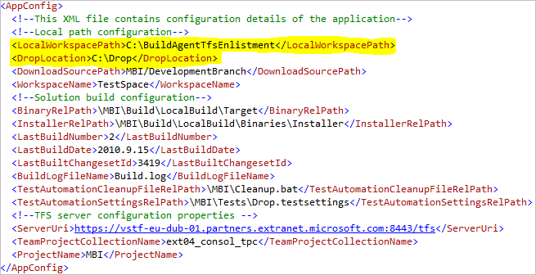

### Build Agent Workflow

The build agent process (**TFSLocalBuildAgentConsole.exe**) executes the following steps:

* Load XML configuration file
* Connect to TFS server using credentials of logged on user
* Get latest changeset id from server
* If latest changeset is newer than last changeset built
  + Delete local workspace
  + Download latest changeset
  + Build solution
  + Assign build number
  + Copy binaries, installer and build log to drop location
  + Save last built changeset id to XML file
* Stop.